Class VII Social Science : Chapter 1
Geography: Geographical Diversity of India.
Following are some of the important facts about its location and extent:
- India is located in both the Northern Hemisphere and the Eastern Hemisphere.
- Latitude – 8°4 N to 37°6’N
- Longitude – 68°7’E to 98°25’ E
- India is a large country with a total area of about 3.28 million square kilometres.
- It extends about 3,200 km from north to south (Kashmir to Kanyakumari) and 2,933 km from east to west (Arunachal Pradesh to Kutch in Gujarat).
- It also has a long coastline of about 7,516 km (including islands) touching many states.
- The northernmost point of India is Indira Col, while the southernmost point is Indira Point in the Andaman and Nicobar Islands, located at 6°45' North. Indira Point got submerged in 2004 due to a tsunami.
- The Tropic of Cancer (23°30′N) passes through the middle of India and divides the country into two almost equal parts - northern and southern India.
- IST is calculated from the Standard Meridian of India which is at 82°30' East longitude and passes through Prayagraj in Uttar Pradesh.

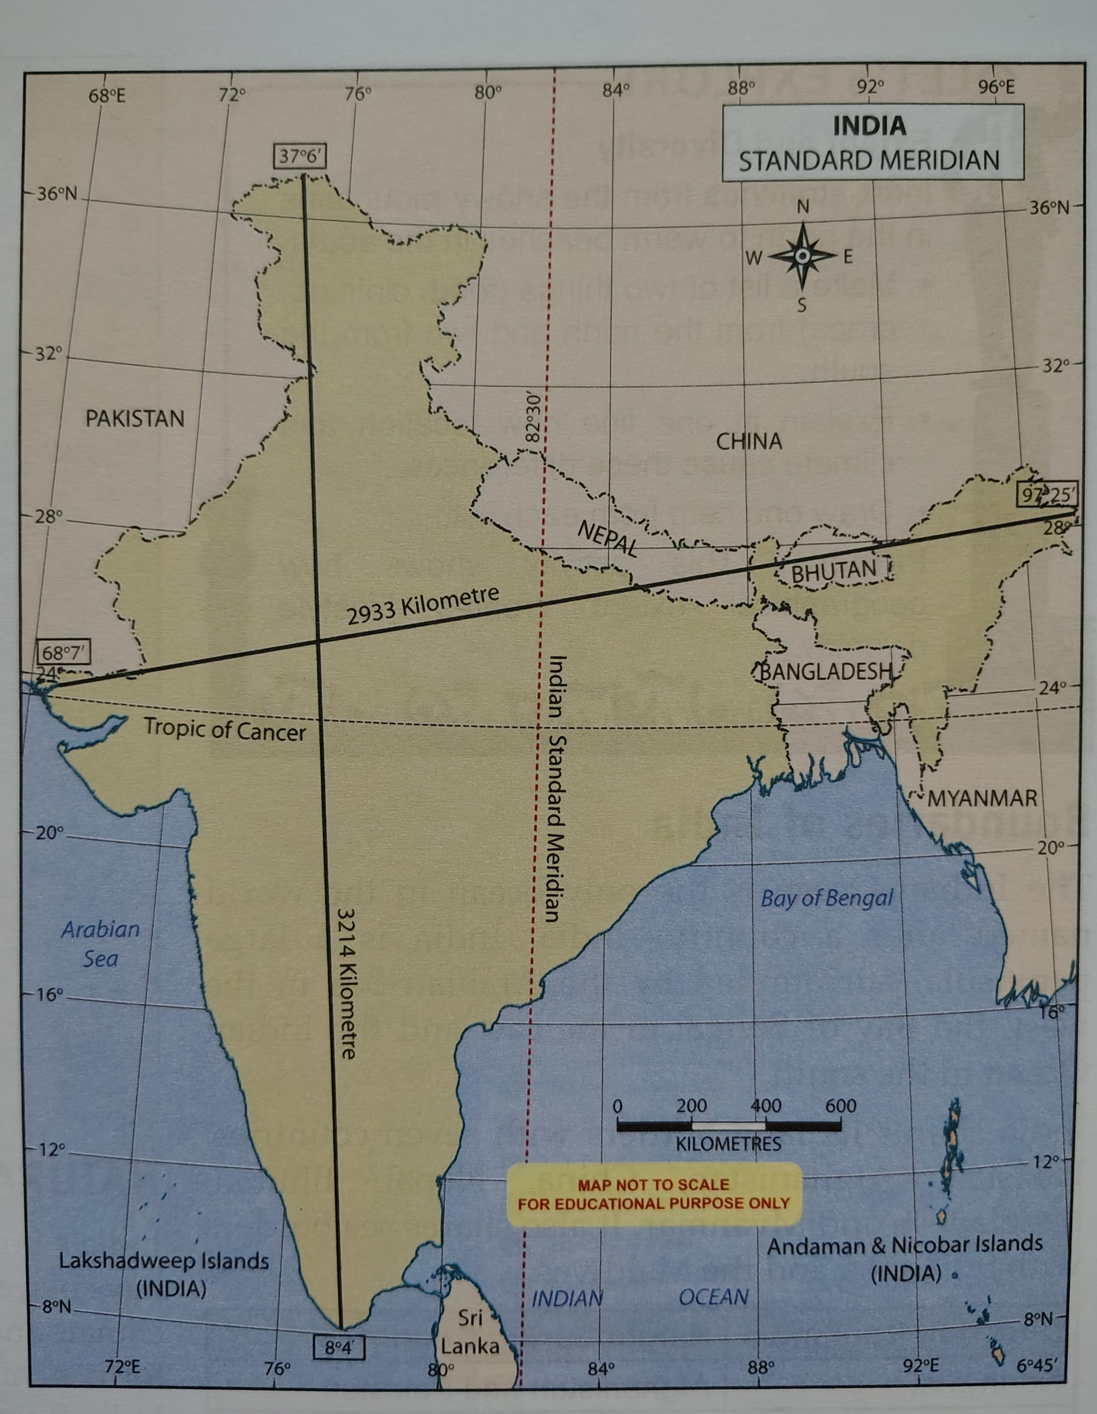
​Formation of the Himalayas:
  - ​Concept: The Himalayas were formed approximately 50 million years ago when the Indian landmass (formerly part of Gondwana) collided with Eurasia.
  - ​Process: The land between the two masses crumpled and rose up, similar to a carpet wrinkling when pushed.
  - ​Ongoing Change: India continues to push into Asia at about 5 cm per year, causing the Himalayas to grow approximately 5 mm taller annually.

    - ​The "Water Tower of Asia": The Himalayas store vast amounts of snow that melt in summer to feed major perennial rivers like the Ganga, Indus, and Brahmaputra.
    - ​Lifeline of the Plains: These rivers provide water for drinking, farming, and industry, supporting hundreds of millions of people.
          - ​Peninsula: A piece of land surrounded by water on three sides (e.g., Southern India).
          - ​Archipelago: A group or chain of islands (e.g., Lakshadweep and Andaman & Nicobar).
          - ​Delta: A fan-shaped landform at a river's mouth formed by sediment deposits (e.g., Sundarbans).

          - ​Disaster Resilience (Architecture):
            - ​Kath-kuni Style: In the western Himalayas, houses are built using a combination of local stone and wood. This "kath-kuni" or "dhajji-dewari" style keeps interiors warm and is resistant to mild earthquakes.
          - ​Economic Geography:
            - ​Hydroelectricity: High-altitude waterfalls, such as Jog Falls, are utilized to turn turbines and generate electricity (hydroelectricity).
            - ​Mining: The Aravalli Hills are rich in minerals like marble, zinc, and copper, supporting centuries of construction and industrial activity.

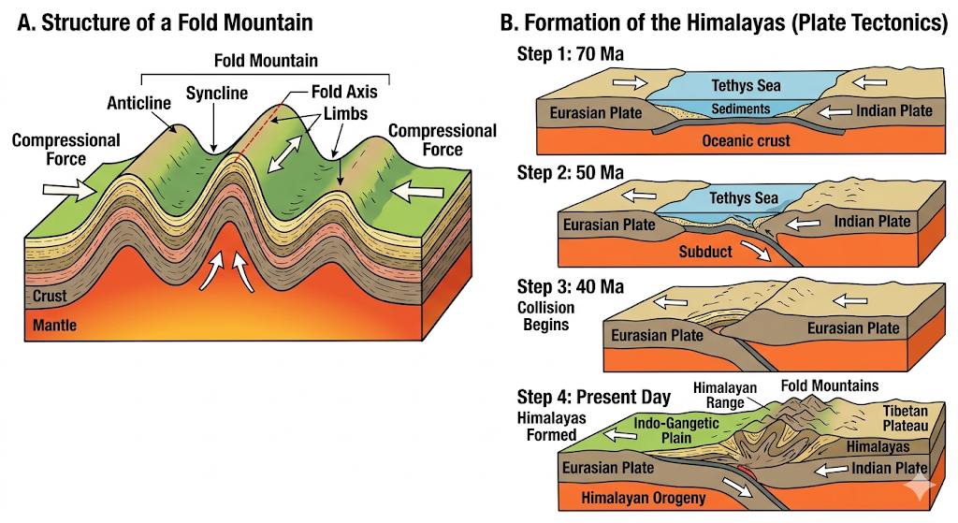

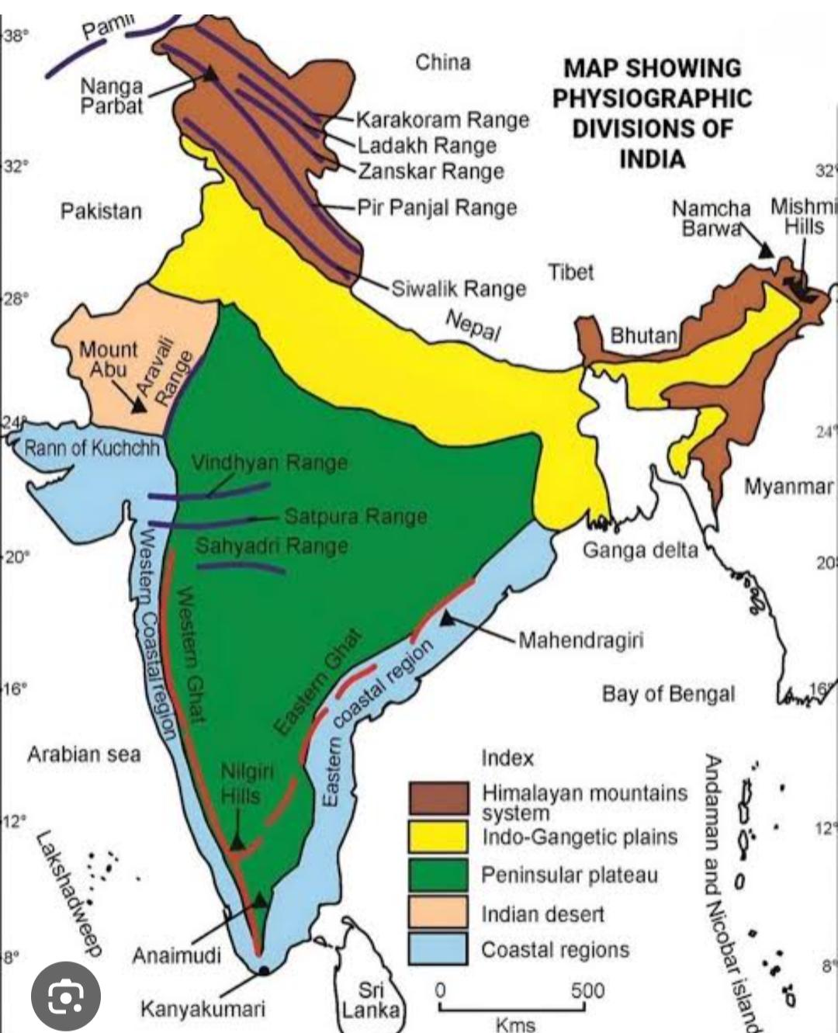

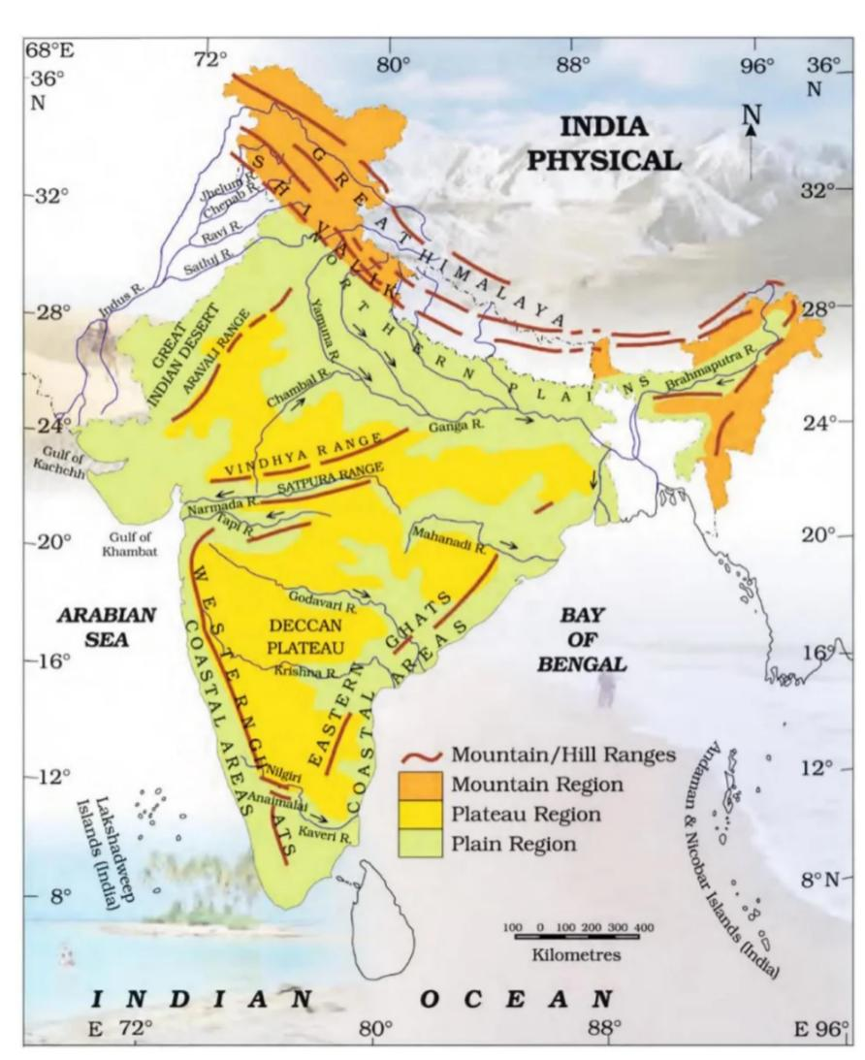

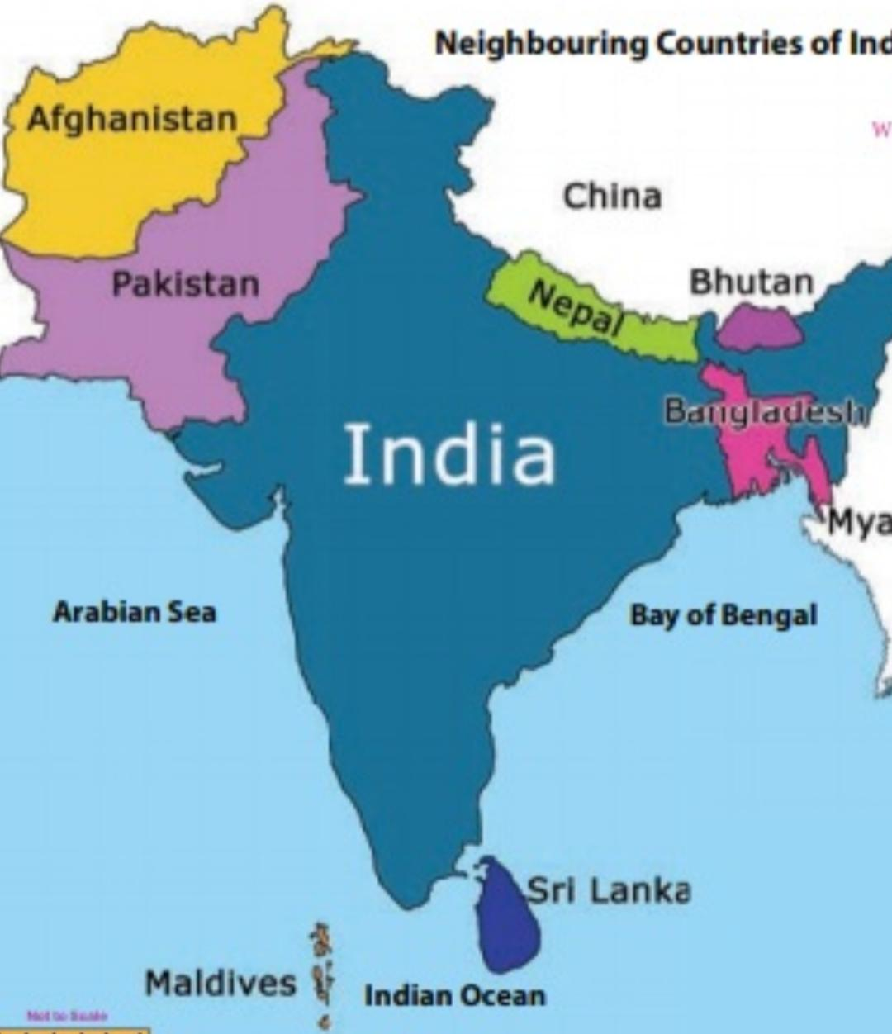

MCQ’S For Practice
1.Which of the following best explains why the Himalayas are referred to as the 'Water Tower of Asia'?
A) They act as a massive wall blocking cold winds.
B) Their melting snow feeds major perennial rivers like the Ganga and Indus.
C) They are the highest mountains in the world.
D) They contain many sacred temples and monasteries.

2. How does the 'kath-kuni' style of house construction in the western Himalayas demonstrate adaptation to the environment?
A) It uses imported materials to ensure luxury.
B) It uses a combination of local stone and wood to resist earthquakes and retain warmth.
C) It is designed to be easily moved during the summer.
D) It is built high above the ground to avoid desert sand.
3. If you are traveling from Jodhpur in the Thar Desert to Mount Abu in the Aravallis, what is the most significant geographical change you will observe?
A) A transition from high-altitude snow peaks to flat plains.
B) A change from arid sand dunes to ancient mountain ridges and cooler altitudes.
C) Moving from a dense tropical forest to a coral archipelago.
D) Traveling from a volcanic island to a fertile river delta.

4.A farmer in the Gangetic Plains is likely to have a more successful harvest than a farmer in Ladakh because:
A) The Gangetic Plains have rocky terrain and very little rainfall.
B) The Gangetic Plains are located at a higher altitude.
C) Ladakh has a moderate climate suitable for all types of crops.
D) The soil in the plains is enriched with minerals by river systems, unlike the rugged terrain of Ladakh.

5.Assertion (A): The Aravalli Hills are crucial for the climate of northwestern India. Reason (R): They act as a natural barrier that prevents the eastward expansion of the Thar Desert.
A) Both A and R are true, and R is the correct explanation of A.
B) Both A and R are true, but R is not the correct explanation of A.
C) A is true, but R is false.
D) A is false, but R is true.
6.Assertion (A): The Western Ghats are home to many swift-flowing rivers that form estuaries.
Reason (R): These rivers originate in the mountains and have a short, steep journey to the Arabian Sea.
A) Both A and R are true, and R is the correct explanation of A.
B) Both A and R are true, but R is not the correct explanation of A.
C) A is true, but R is false.
D) A is false, but R is true.

7.Read the following statements regarding the Indian Islands:
Statement I: Lakshadweep is an archipelago of 36 coral islands in the Arabian Sea.
Statement II: The Andaman and Nicobar Islands contain India's only active volcano on Barren Island.
A) Only Statement I is correct.
B) Only Statement II is correct.
C) Both Statement I and II are correct.
D) Neither Statement I nor II is correct.

8.Read the following statements regarding the Peninsular Plateau:
Statement I: The Deccan Plateau tilts slightly to the west, causing all major rivers to flow into the Arabian Sea.
Statement II: It is a very old land formation surrounded by water on three sides.
A) Only Statement I is correct.
B) Only Statement II is correct.
C) Both Statement I and II are correct.
D) Neither Statement I nor II is correct.

9.Match the region with its defining characteristic:
1.Ladakh —— a) Golden City (Jaisalmer)
2.Thar Desert —— b) Moonland
3.Himalayas —— c) Fertile Deltas
4.East Coast —— d) Water Tower of Asia
Options:
A) 1-b, 2-a, 3-d, 4-c
B) 1-a, 2-b, 3-c, 4-d
C) 1-b, 2-c, 3-a, 4-d
D) 1-d, 2-a, 3-b, 4-c
10.Match the Mountain Range with its description:
​1.Himadri —— a) Outer Himalayas with rolling hills
​2.Himachal —— b) Oldest mountains in the world
​3.Shivalik —— c) Highest, ruggest part (Greater Himalayas)
​4.Aravallis —— d) Moderate climate with popular hill stations
Options:
A) 1-d, 2-c, 3-b, 4-a
B) 1-b, 2-a, 3-d, 4-c
C) 1-c, 2-a, 3-d, 4-b
D) 1-c, 2-d, 3-a, 4-b

Subjective Questions
1.Explain how the collision of the Indian landmass with Eurasia millions of years ago continues to affect the height of the Himalayas today.
2.Contrast the water conservation challenges faced by people in the Thar Desert with those in the Gangetic Plains. How have they adapted?
3.Why would the flat terrain of the Northern Plains be more conducive to building an extensive railway network compared to the Western Ghats?

4.Describe the three main ranges of the Himalayas, including their climate and habitation patterns.
5.Discuss the importance of the Peninsular Plateau to India's economy in terms of minerals, rivers, and forests.
6.Explain the geographical significance and location of the two major island groups of India.

7.Using a physical map of India, identify the states through which the Aravalli range passes and name its highest peak.
8.Sketch a diagram showing the formation of the Himalayas using the "carpet wrinkle" analogy mentioned in the text.

​
9.You are visiting the Sundarbans. Based on its geography, what unique combinations of river, sea, and land features would you expect to see, and which famous animal might you encounter?
10.Imagine you are living in Mawlynnong village. What daily practices would you follow to maintain its reputation as the "cleanest village in Asia"?

